LAB4
4. Get the logins name and full names (comment) of logins starts with “g”.
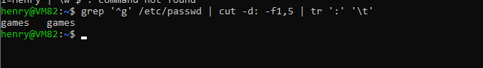
5. Save the output of the last command sorted by their full names in a file
LAB5
1. Compress a file by compress, gzip, zip commands and decompress it again. State the differences between compress and gzip commands.
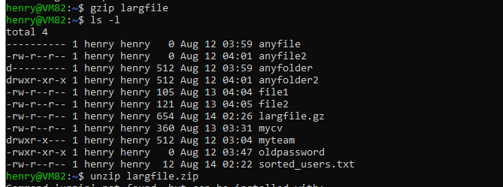
2. What is the command used to view the content of a compressed file.
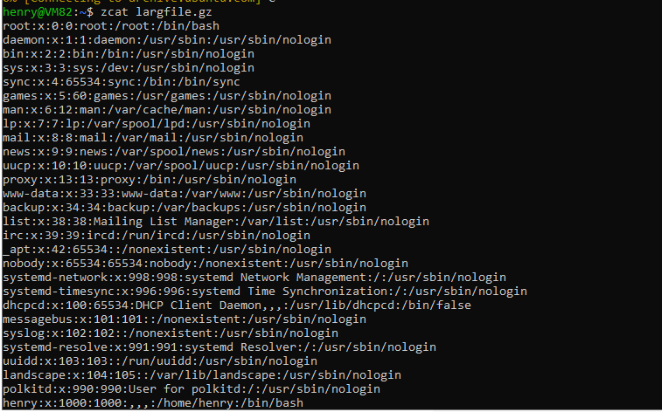
3. Backup /etc directory using tar utility.
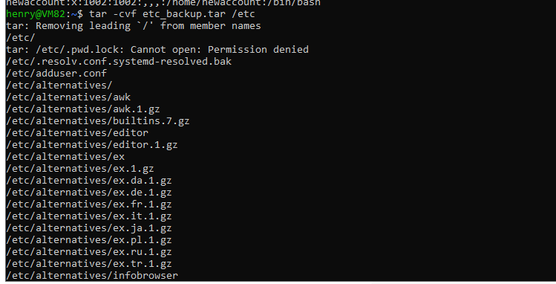
4. Starting from your home directory, find all files that were modified in the last two day.
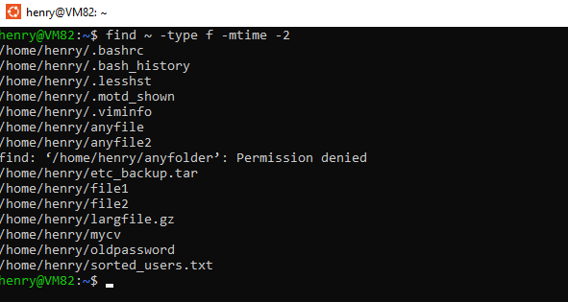
5. Starting from /etc, find files owned by root user.
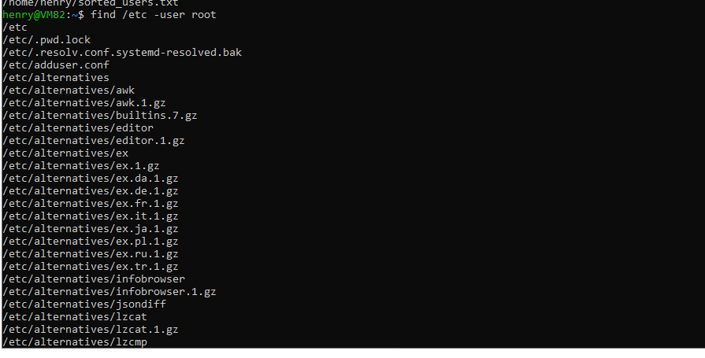
6. Find all directories in your home directory
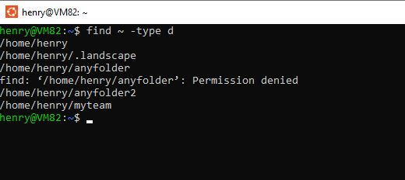
7. Write a command to search for all files on the system that, its name is “.profile”.
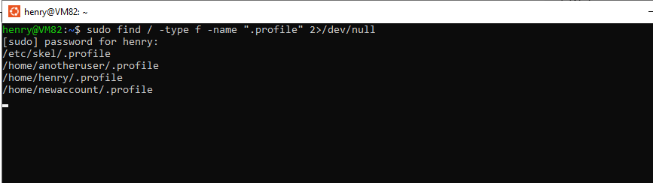
8. Identify the file types of the following: /etc/passwd, /dev/pts/0, /etc, /dev/sda
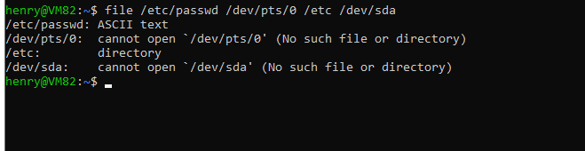
9. List the inode numbers of /, /etc, /etc/hosts.
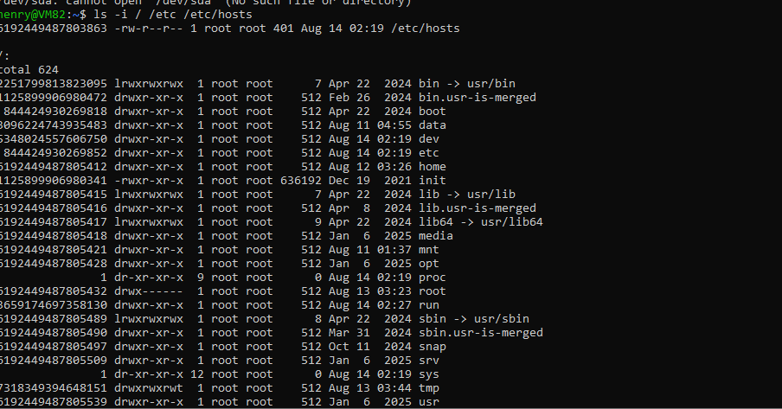
10. Copy /etc/passwd to your home directory, use the commands diff and cmp, and Edit in the file you copied, and then use these commands again, and check the output
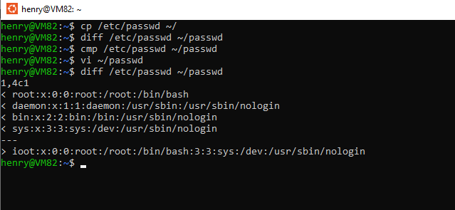
11. Create a symbolic link of /etc/passwd in /boot.
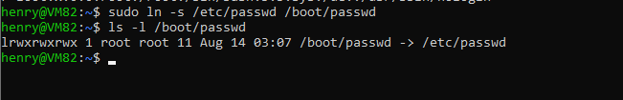
12. Create a hard link of /etc/passwd in /boot. Could you? Why?
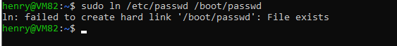
- hard link لازم يكون على نفس النظام/قسم الملفات (filesystem).
/etc/passwd عادة بيكون في القسم الجذري /، و/boot ممكن يكون قسم منفصل (partition) أو نظام ملفات مختلف.
إنشاء hard link عبر أقسام مختلفة غير مسموح في لينكس.

